|  |  |
| --- | --- |
| Week | Topics |
| 1 | Revision / Internet |
| 2. | Internet Browser |
| 3. | Benefits of the Internet |
| 4. | Internet Environment |
| 5 | News Group |
| 6. | File sharing |
| 7and 8 | Computer ethic (ii) |
| 9. | Safety measures 1 |
| 10. | Safety measures 2 |
| 11. | Revision |
|  |  |

Scheme of work for 3RD TERM

WEEK : 1 REVISION

CLASS : JSS TWO WEEK : 2

INTERNET

The global communication network that allows almost all computers worldwide to connect and exchange information. It is a network of networks (largest computer network in the world!).

The internet could also be define as the collection of computers linked together to share information worldwide.

RESOURCES PROVIDED BY THE INTERNET

1. E mail (Electronic mail): is a service provided by the internet which allows users to send and receive mails via the computers
2. Gopher: this is system that allows the creation and use of directories of files on the computers on the internet and build links that allows users to browse through the files.
3. File transfer protocol (FTP): this allows transfer of files between host computer
4. Usenet: this allows automatic distribution of news among thousands of user groups called news groups.
5. Telnet: this allows a user to log in to a remote computer and make use of it.
6. Web page: this is a document or resource of information that is suitable for the World Wide Web and can be accessed through a web browser. Web pages are accessed through their web address. Examples of web addresses are :

[www.gooogle.com](http://www.gooogle.com)

[www.yahoo.com](http://www.yahoo.com)

[www.facebook.com](http://www.facebook.com)

1. Website : this is a collection of web pages ,just like a book with multiple pages.
2. Hyperlink : connects webs pages on the internet by using text or images as a links to connect to other web pages or sites .
3. World wide web (www) : is defined as the global information medium which users can read, write and access information via the computers connected to the internet.

**INTERNET BROWSER**

An *internet browser*, also known as a *web browser* or simply a browser, is a software program that you use to access the internet and view web pages on your computer. You can think of your browser as your gateway to the internet. A web browser is a computer application software with which websites can be viewed.

**Examples of the internet browser** include

Mozilla Firefox

Microsoft Internet Explorer

Apple safari

Google Chrome

Opera etc

**CREATING AN EMAIL ACCOUNT**

Crating an email account allows you th have an email address which can be used to send and receive mails from friends and loved ones .some email accounts are created with Yahoo mail, hotmail, MSN etc and are free for internet users.

To create a free account with Yahoo mail ,follow the steps below

1. Open the web browser and type [www.yahoomail.com](http://www.yahoomail.com) in the address bar
2. On the Yahoo web page, click on Sign up
3. Fill in your personal data
4. Type in the proposed email address you want to use
5. Type your password and retype your password to confirm.
6. Type the code shown in the registration window.
7. Click on create my account.

Examples of E-mail addresses

Yahoo :[elias@yahoo.com](mailto:elias@yahoo.com)

Google :[elias@gmail.com](mailto:elias@gmail.com)

Hotmail :[elias@gmail.com](mailto:elias@gmail.com)

EXERCISE

1. Define the Internet

2. State resources provided by the internet

WEEK: THREE

BENEFITS OF THE INTERNET

The internet offers varieties of benefits. These includes

1. Communication / information exchange: with the internet we are able to send and receive e-mails and exchange vital information.
2. E-learning: - this stands for electronic learning which could be defined as the use of computer resources to enhance learning.
3. E-entertainment : the internet can also be a source of entertainment through playing of games ,music , online videos etc
4. Fast and Cheaper Communication Service: the internet minimizes distances and provides communication services efficiently and without little or no cost.
5. E-registration: - the internet provides examination bodies, schools associations etc a simple, cost effective registration service. Examples of such bodies are WAEC,JAMB NECO etc.
6. E-commerce: thousand of businesses can be transacted online with the use of the internet.
7. Research : researches can be made online at little or no cost
8. Social Networking : the internet provide a service where people can connect, chat and meet with various people such as old friends,neigbours ,family members,friends etc .
9. Political campaign: the internet is also used for political campaign by the politicians.
10. Improving Productivity:most establishments now use the internet as a tool for marketing their products and for communication concerns which has helped business to reduce costs thereby improving their productivity.

**INTERNET ABUSE**

**Internet abuse** refers to improper use of the internet and may include:

* [Computer crime](https://en.wikipedia.org/wiki/Computer_crime), use of computers in criminal activity.
* [Cyber-bullying](https://en.wikipedia.org/wiki/Cyber-bullying), use of the internet to bully and intimidate
* [**Malware**](https://en.wikipedia.org/wiki/Malware)**, software designed to harm a user's computer, including computer viruses**
* [Spam (electronic)](https://en.wikipedia.org/wiki/Spam_(electronic)), sending unwanted advertising

EXERCISE

1. State the benefits of the internet

2. mention 3 internet absuses

WEEK FOUR

INTERNET ENVIRONMENT

An internet environment on a typical web browser consists of the following common features

* Back and forward Buttons : are used to move the web pages back and forth
* Refresh button : it reloads the current web page
* Stop Button : it cancels the sloadving action of the current web page.
* Home Button : this is a cmmasnd button that is used to return a user to the home page of the current website.
* Addesss bar : is used to input web page addresses I.e Uniform Resource identifier (URI)
* Search Bar : this is used to input terms into search engine.
* Status Bar : is used to display progress in loading the resource and also the URI of hyperlinks when the cursor hovers over them.
* Menu Bar : contains list of menu used for maniplating web browser and web pages.The web broswers may contain menu options such as Hiastory and Bookmarks which distinguish them from other GUI applications eg Microsoft Word

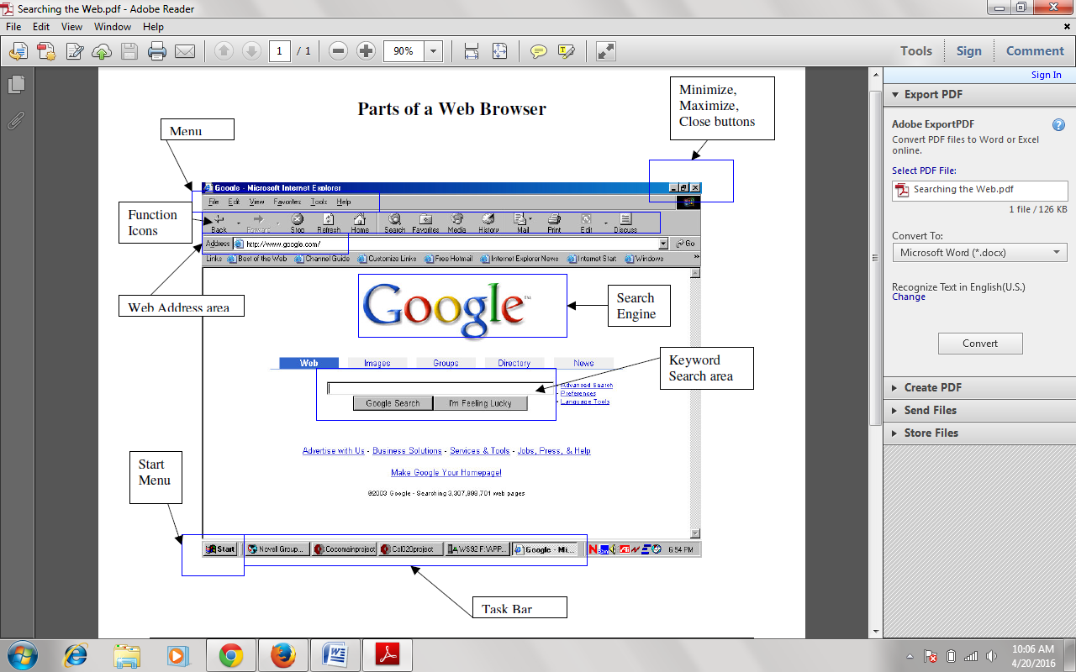

**USES OF THE INTERNET**

The internet is used for

* Sending and receiving emails
* Chatting

EXERCISE

1. Describe the internet browser environment

2. State 3 uses of the internet

WEEK 5

NETWORK GROUPS

**Mailing list**

A mailing list is a collection of names and addresses used by an individual or an organization to send material to multiple recipients. On the Internet, mailing lists include each person's e-mail address . The term is often extended to include the people subscribed to such a list, so the group of subscribers is referred to as "the mailing list", or simply "the list".

**News Group**

Same as forum, it is an on-line discussion group. On the Internet, there are literally thousands of newsgroups covering every conceivable interest.

Newsgroups are discussion groups. To read messages posted to a particular newsgroup, you must first subscribe to the newsgroup.

Newsgroup is an excellent way to share information, to get answers, and to give your opinion to online subjects.

**A USENET SEARCH ENGINE**

This is a service that searches through Usenet newsgroups to find specific content. Usenet search engines can be used to search for anything. For example, you might search for photos of a famous person (such as Bill Gates)

If you want to search for regular, text-based articles, the easiest way is to use the Google Groups Web site.

EXERCISE

Define the following terms

1. Mailing list

2. Newsgroup

WEEK 6

FILE SHARING

**File Sharing**

Network file sharing is the process of copying data files from one computer to another using a live network connection.

Before the Internet and home networks became popular, data files were often shared using floppy disks. Nowadays, some people still use CD-ROM / DVD-ROM disks and USB sticks (Flash drives) for transferring their photos and videos, but networks give you more flexible options.

**FTP File Transfers**

This is a method of sharing files where a central computer called the FTP server holds all the files to be shared, while remote computers running FTP client software can log in to the server to obtain copies.

**P2P - Peer to Peer File Sharing**

Peer to peer (P2P) file sharing is a popular method for swapping large files on the Internet, particularly music and videos. Unlike FTP, most P2P file sharing systems do not use any central servers but instead allow all computers on the network to function both as a client and a server.

**NETWORK**

A *computer network* is a set of *computers* connected together for the purpose of sharing information and resources. Networks are used to provide easy access to information, thus increasing productivity for users.

**Benefits of networking**

There are three main benefits of a network

**File Sharing**

In a computer network, one can view, modify, and copy files stored on a different computer on the network just as easily as if they were stored on your computer.

**Resource Sharing**

Resources such as printers, fax machines, Storage Devices (HDD, FDD and CD Drives), Webcam, Scanners, Modem and many more devices can be shared in a network.

Program Sharing

One can also share programs on a network. For example programs such as Microsoft Office, can be shared by computers in the network.

**Types of Networks**

**Local Area Networks**

Local area network (LANs) is a type of network connected within a very close geographic area, such as a floor of a building.

**Metropolitan Area Networks**

This is a large computer network which extends to a city or town or a community.

**Wide Area Networks**

This is a computer network in which the computers connected may be far apart. This network could exist between a city and another city, or even between two countries.

**Intranet**

An intranet is basically a network that is local to a company. In other words, users from within this company can find all of their resources without having to go outside of the company.

**Extranet**

An extranet is an extended intranet, where certain internal services are made available to known external users or business partners at remote locations.

EXERCISE

1. Define file sharing

2. Explain the term Network

WEEK: 7-8

COMPUTER ETHICS II

**RESPONSIBLE USE OF THE COMPUTER**

Computer system is a valuable and expensive piece of equipment that requires that must be properly maintained. Therefore, the following rules should be adhere to

1. Avoid liquid from coming in contact with the computer system
2. Cover the system with transparent covers when not in use to prevent dust from entering into them
3. Ensure that computers system are connected to properly charged UPS systems to prevent them from damages due to power surge or failures
4. Unplug the computer system from power source and all electrical gadgets before leaving the office at the end of the day.
5. Food particle should not be allowed to penetrate the keyboard.
6. Make use of surge protectors to prevent electric surge from damaging the computers.

**RESPONSIBLE USE OF THE INTERNET**

1. Always endeavour to check your e-mail regularly
2. The content of your message may be received by another person , so be mindful of your words and write responsibly
3. Always spell check your messages before they are sent
4. Be mindful of the websites you visit, some sites are very dubious waiting for victims; others contains pornographic contents which is considered immoral in the society .
5. Install Anti-Virus in your computer and avoid file attachments from unknown sources to prevent virus attacks
6. While chatting, be mindful of how you exchange information about yourself .

**MISUSE OF COMPUTERS AND THE INTERNET**

Computers and the internet are misused by the users in the following areas

1. **Hacking**: is an act of gaining unauthorized access to computers. Anyone who does the act is called a Hacker.
2. **Computer virus**: virus are programs that damage our files. A lot of viruses are contacted through the internet by infected CDs , flash drives, ficticious emails etc
3. **Fraud** : scam letters and false information are sent through emails and mailing lists to fraudulently collect money and other valuable items from innocent/ ignorant person
4. **Stealing (or Phishing ):** internet criminals engage in stealing vital information such as ATM card Pin, email Password, username etc. from victim’s website , emails and even personal computers .
5. **Pornography**: the internet is the medium for the distribution of pornographic materials.
6. **Cyber War :** cyber war is the use of computers, the internet and other devices to attack the enemies of information system.
7. **Piracy :** this is use of computer to duplicate other people’s work illegal especially CD, DVD , tapes , films, software etc.
8. **Plagiarism:** this entails copying another person’s work such as music , books, etc. without prior written permission and presenting it as one’s work.

EXERCISES

What is Computer Ethics ?

WEEK: 9-10

SAFETY MEASURES

To protect the computer system and the computer personnel, some safety measures must be taken and they are as follows

1. Good sitting posture should be maintained ( i.e.) always sit straight )
2. Anti-glare protector (monitor filter) should be used to protect the eyes.
3. The monitor should be positioned to the eye level to avoid bending.
4. A computer room must be properly lit.
5. The computer environment must be clean and free from dust.
6. Liquid should be avoided completely in the computer system
7. There should be no beside the eating and drinking beside the computer system
8. Computer system and peripherals should be arranged in the computer room so as to allow free entry and free exit
9. The computer room should be air conditioned.
10. Unauthorized personnel should not be allowed into the computer room.